

**LA GRANDEE INTERNATIONAL COLLEGE**

**Simalchaur, Pokhara Nepal**

A Project Report

On

**“Bookly”**

**Submitted to:**

Bachelor of Computer Application (BCA) Program

In partial fulfilment of the requirements for the degree of BCA under

Pokhara University

**Submitted by:**

|  |  |  |  |
| --- | --- | --- | --- |
| **Name:** | **Course** | **Semester** | **P.U. Registration Number** |
| Bishal Adhikari | BCA | 6th | 2021-1-53-0348 |
| Deepak Chhantyal | BCA | 6th | 2021-1-53-0349 |
| Roshan Adhikari | BCA | 6th | 2021-1-53-0363 |
|  |  |  |  |

**Date: January 20, 2025**

# Acknowledgement

We would like to express our gratitude to our project supervisor Mr. Sunil Sapkota and BCA coordinator Mr. Kundan Chaudhary for guiding us throughout the project. And we are thankful toward each other we worked as a team supportively.

Sincerely,

Bishal Adhikari (PU Exam Roll no): 21535149

Deepak Chhantyal (PU Exam Roll no): 21535150

Roshan Adhikari (PU Exam Roll no): 21535164

**Declaration for**

**“Bookly”**

# Student’s Declaration

We hereby declare that we are the only authors of this work and that no source other than the listed here have been used in this work. We guarantee that the work we have presented is entirely our own, and any similarity to other projects is purely coincidental.

Bishal Adhikari (21535149):

Deepak Chhantyal (21535150):

Roshan Adhikari (21535164):

Program: BCA, 6th Semester

Date: January 20, 2025

# Letter of Approval

We certify that we have examined this report entitled “**Bookly**” and are satisfied with the project defense. It is satisfactory in the scope and quality as project in partial fulfilment of the requirement for the degree of **BCA** under **Pokhara University.**

|  |  |  |
| --- | --- | --- |
| ___________________  **Supervisor**  Mr. Sunil Sapkota  Ast. Professor  LA GRANDEE International College | __________________  **External Examiner**  Er.  Ast.Professor  College  Date: January 20, 2025 | ____________________  **Program Coordinator**  Mr. Kundan Chaudhary  Ast. Professor  LA GRANDEE International College |
|  |  |  |

# Abstract

Bookly is an online platform that makes buying and selling books easy and easy. It has variety of books with different genres and categories. With titles indexed in search by users favorite terms, it is possible to search for their favorite titles to help them filter out the option that would do well.

The website is very simple, secure payment options and tracking of orders according to user preferences are available. Bookly is also used to sell books from independent authors and publishers.

Bookly is built with the focus on the accessibility, affordability and sustainability while delivering the joy of reading towards the world.

**Table of Contents**

Acknowledgement ii

Student’s Declaration iii

Letter of Approval iv

Abstract v

1. Introduction 1

2. Problem Statement 2

3. Objectives 3

4. Background Study 4

5. Requirement Document 5

5.1 Requirement Matrix: 5

5.2 Types of Requirement 6

6. System Design 7

6.1 Data Flow Diagram 7

6.2 ER-Diagram 9

7. Development 11

7.1 Development Methodology 11

7.2 Work Assign 12

7.3 Project Gantt chart 13

8. Testing 14

8.1 Test Cases 14

9. Project Result 19

10. Future Enhancements 20

11.Conclusion 21

12. References 22

List of Figures

Figure 5.1: Requirement Matrix 5

Figure 6.1: Level 0 DFD 7

Figure 6.2: Level-1 DFD 8

Figure 6.3: Er-Diagram 10

Figure 7.1: Spiral Model 11

Figure 7.2: Work Assign 12

Figure 7.3: Gantt Chart 13

Figure 8.1: Testing Login 14

Figure 8.2: User homepage Test 15

Figure 8.3: Admin Dashboard Test 16

**Abbreviations**

|  |  |
| --- | --- |
| SQL: | Structure Query Language |

# Introduction

Bookly is an eCommerce solution that implementing the concept of buying and organizing books based on its simplicity for both an end user and a system administrator. Convenience along with accessibility became the name of the game in today’s fast growing world of online shopping, however, most services do not offer a completely fulfilling experience. Since this void is lacking, Bookly serves as a solution designed for both the avid book lovers and the administrators.

As for the users, Bookly provides them with an opportunity to use the site’s simple navigating option, which makes it possible to find various books. Users can sort the information as they like, using the search options, like genre, author, and keywords, to find a new book. Users are also able to access more specific data about books to select which they want to be added to a cart where they can be bought easily.

From the perspective of the administrative side, there are features for the effective management of the platform. The use of this inventory means that administrators are able to have CRUD functionality that enables them to constantly update the inventory information. They can also direct user orders and determine whether to accept or reject them, due to stock or for any other reason.

Some of the accomplishments recorded in the course of the project implementation are the provision of user authentication, sign-up as well as an order placement mechanism. However, ambitious work is still afoot, for example, ensuring that is a safe and easy payment solution. The plan for further development is about implementing the support for the most widespread domestic payment gateways such as Khalti and eSewa to meet Nepali clients’ requirements.

Bookly’s goal is not to become just an online selling service; though, it is much than this. Using elements like individual recommendations, easy to navigate layout, and fast checkout, it is designed to foster a strong community of bibliophiles. The work stays concentrated on reconciling the features and usability in order to remain competitive and show Bookly as a progressive and versatile solution for eCommerce.

# Problem Statement

Despite the increasing digitization of book shopping, existing online systems still face several challenges:

* Poor Search Capabilities: Many platforms lack advanced search features, making it difficult for users to find books based on author, genre, or keywords.
* Inefficient Cart Management: Users often encounter difficulty in managing items in their cart, such as updating quantities or removing books.
* Limited Administrative Tools: Administrators face challenges in performing CRUD operations, monitoring orders, and keeping track of inventory.
* Lack of Payment Integration: Existing systems often fail to support region-specific payment gateways, leading to inconvenience for users.

# Objectives

The goal of a bookly is to give book buyers and sellers an opportunity for easy, comfortable and safe book purchasing and selling. Here are some key objectives:

* To make user-friendly online platform where customers can shop book of their choice on their comfort.
* To increase the bookstore’s customer base by providing wide variety of books to the readers.

# Background Study

When the formation of the team occurred, we started researching the concepts in order to select a project that could be useful, meaningful, and feasible. Thus, our main goal was to create a system that would help to overcome issues characteristic of people’s daily experiences. Our study showed that current e-Commerce sites involved in the sale of books do not support basic functionalities such as proper stock management, offering recommended books to customers, among others. This took us into the creation of the project known as “Bookly – An Online Bookstore.”

Despite the fact that contemporary book stores are conveniently redesigning the way true book lovers shop for books, some platforms are still lacking an all-encompassing solution. There exists problems like weak search options, poor grouping of books categories, and absence of localized payment methods. Noting these issues, our goal was to design a digital system which not just addresses these issues but also improves the generalized process of finding and buying books as well.

Bookly aims at being user-friendly, time-saving and all in one place for book lovers and administrators. Pursuing to fill the existing voids of other online bookstores, the platform aims to developers into providing a smooth experience to the users and the administrators can efficiently operate the system.

# Requirement Document

While developing a project, requirements are necessary. Without requirements, a project cannot be developed. It outlines the essential features and functionalities necessary for efficiently organizing and coordinating futsal events.

## **5.1 Requirement Matrix:**

|  |  |  |  |  |
| --- | --- | --- | --- | --- |
| SN. | Required modules, system and features. | Description for the modules | Priority (High, Moderate, low) | Remarks |
| 1. | Login and security system | User should be able to register and login with valid details. | High |  |
| 2. | Registration and user profiles | User registration, user individual profile section. | High |  |
| 3. | Cart | User should be able to add to cart, view and update quantities. | High |  |
| 4. | Payments | Payment integration after purchasing of books. | High |  |
| 5 | Books inventory | Admin able to add , edit or remove book , update details, quantity of books in inventory. | High |  |
| 6 | Admin Profile | Admin should able update own profile | High |  |

Figure 5.1: Requirement Matrix

## **5.2 Types of Requirement**

## **User Requirement**

* **For customer**

1. Ability to register, login and manage their profiles.
2. Search for book by title, author, genre
3. View detailed information about books
4. Add book to cart and proceed to checkout
5. Securely make payments

* **For Admin**

1. Manages book inventory
2. Monitor and update stock levels
3. Order management

**Functional requirements**

* **User Account Management:** User registration, login/logout
* **Book Catalog and search:** Book catalog with categories and searching and filtering capabilities.
* **Cart and checkout:** Add or remove book, update books quantities etc.
* **Order Processing:** process order and confirm orders.
* **Inventory management(Admin):** Book management

## **Nonfunctional requirements**

* **Security**: The system will be secured, and management of configuration and errors.
* **Reliability**: The system operates free of failure and reliable with the hardware.
* **Data Integrity**: The system will have the efficient data collection, store access and usage.
* **Performance**: Provide a minimum response time, while with the user interactions.

# System Design

System Design is the process of designing the elements of a system such as modules, interfaces and the data that goes through that system. We represent the design of our system by using DFD diagram.

## **Data Flow Diagram**

Data Flow Diagram (DFD) is a graphical representation of the flow of data and used to visualize how data is flow, process and stored within a system. The DFD of our system:

### **6.1.1 Level-0 DFD**

**Indexes:**

* **External Entity**
* User(customer)
* Admin

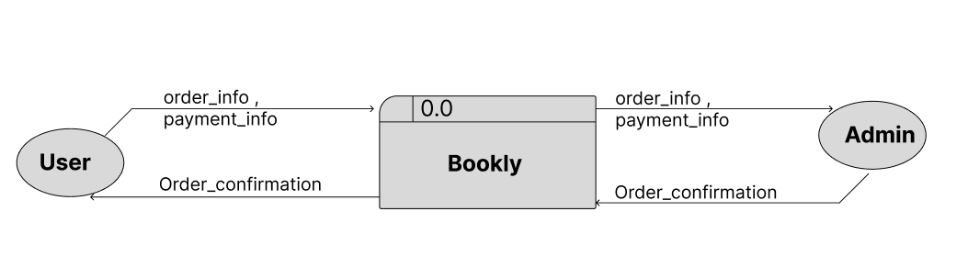

Figure 6.1: Level 0 DFD

### **6.1.1 Level -1 DFD**

Indexes:

1. External Entity

* User
* Admin

1. Processes

* Register/login(1.0)
* Manage books(1.1)
* Browser books(1.2)
* Order Payment(1.3)
* Order Books(1.4)
* View Order(1.5)
* View Payment(1.6)
* Approve Order(1..7)

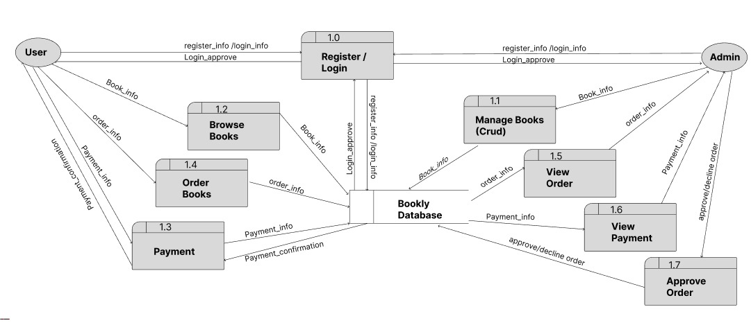

Figure 6.2: Level-1 DFD

## **ER-Diagram**

Entity-Relationship (ER) diagram for a Bookly involves identifying the main entities, their attributes, and the relationships between them. Here's a simplified ER diagram for a bookly(book store website):

**Entities:**

* **User**
* **Books**
* **Admin**
* **Order**
* **Cart**

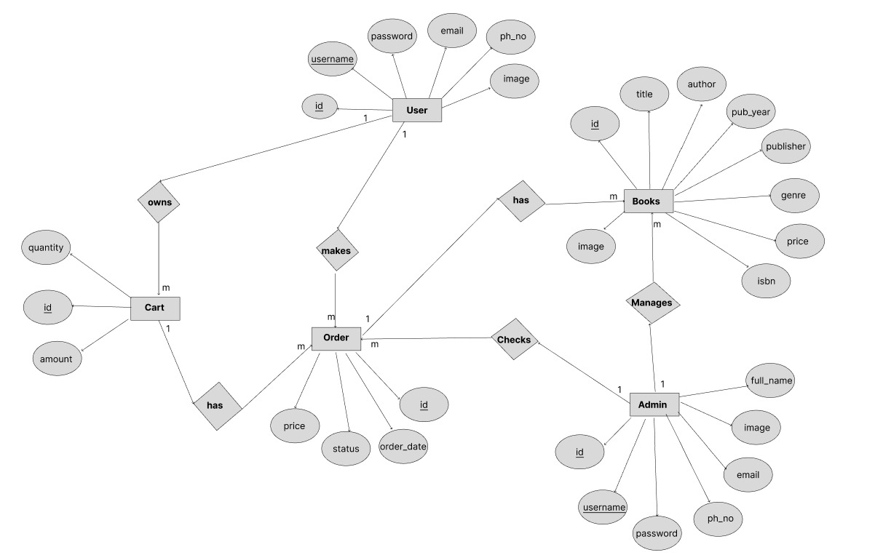

Figure 6.3: Er-Diagram

# Development

Project development is the process and the facility of planning, organizing, allocating resources to fully develop a project. Development is basically a roadmap to provide a guidance to develop and build a project. On the documentation of a project, we have use MS-Word., which allows us document the report. We use a web application “Lucid Chart “for the DFD and Flowchart of the system. For the Gantt chart of the project progress, MS-Excel is used.

## **7.1 Development Methodology**

We have use “Spiral Model” for the development of our project.

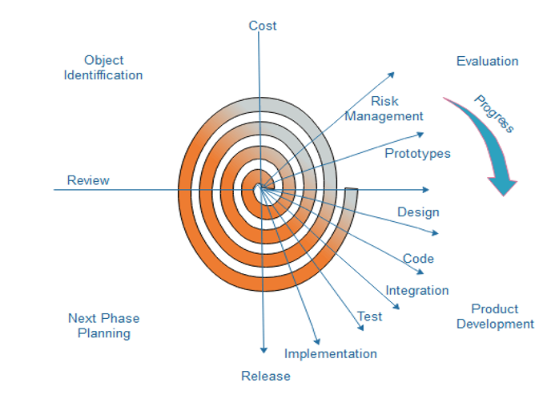

Figure 7.1: Spiral Model

## **7.2 Work Assign**

The following table shows the activities done by the team members:

|  |  |  |  |
| --- | --- | --- | --- |
| S.N. | Name of the member | Work assigned | Remarks |
| 1. | Bishal Adhikari | * Document * Problem Identification * System Design * System coding |  |
| 2. | Deepak Chhantyal | * Documentation * Planning * System Coding * System Design * Testing |  |
| 3. | Roshan Adhikari | * Testing * Coding * Requirement Document * Documentation |  |

Figure 7.2: Work Assign

## **Project Gantt chart**

In the context of developing a Bookly, a Gantt chart for the project includes various tasks and milestones related to the system's development.

Figure 7.3: Gantt Chart

# Testing

Test Objectives

Testing is the process of validating the correctness of a program.

* 1. Test Cases

Title: Module testing of a login function- Authentication

Description: A user should be able to log in using the proper username and password.

|  |  |  |  |
| --- | --- | --- | --- |
| Test Case ID | Test Case | Input | Expected result |
| 1.1 | Verify User registration | Fill all required fields and submit | User account created |
| 1.2 | Verify Login functionality | Enter valid email and password | User logged in and redirected to homepage |
| 1.3 | Verify Login with invalid credentials | Enter incorrect email or password | Error message “invalid details” displayed |

Figure 8.1: Testing Login

Title: Testing user homepage

Description: User can access the homepage after redirected to webpage.

|  |  |  |  |
| --- | --- | --- | --- |
| Test Case ID | Test Case | Input | Expected result |
| 2.1 | Verify book listing page | Navigate to product page | Book display with details |
| 2.2 | Test search functionality | Enter book title or author in search bar | Relevant books displayed |
| 2.3 | Verify adding a book to cart | Select a book and click “Add to cart” | Book added to cart with correct price |
| 2.4 | Update the book quantity in cart | Increase or decrease book quantity in the cart | Cart total update accurately |
| 2.5 | Verify removing a book from the cart | Click “Remove” on a book in the cart | Book removed from the cart |
| 2.6 | Verify proceed to checkout | Provide valid payment and shipping details | Order placed, confirm |

Figure 8.2: User homepage Test

Testing Admin Dashboard

Title: Testing Admin Dashboard

Description: Functionality of admin dashboard can be use.

|  |  |  |  |
| --- | --- | --- | --- |
| Test Case ID | Test Case | Input | Expected result |
| 3.1 | Verify adding a book | Fill the book details in admin panel. | Book added to database and visible to us |
| 3.2 | Verify editing book details | Modify details and price or stock of book | Change reflect in the catalog. |
| 3.3 | Test deleting a book | Remove a book via admin panel | Book delete from the catalog |
| 3.4 | Verify sales and inventory report | Navigate to report section | Book, order and sales report. |
| 3.5 | Test editing admin profile details | Modify a admin picture, details and change password | Admin account details changed |

Figure 8.3: Admin Dashboard Test

# 9. Project Result

The outcomes of the project indicate the creating and applying Bookly which focuses on increasing the usage efficiency of books purchasing and management based on users and administrator for customers.

**Key Achievements:**

**User Login and Registration:** Great consideration has been made to the login mechanism for users and for administrators to have a more secure and well maintained operation of website.

**Efficient Inventory Management:** The operations that the administrators can manages the book inventory within the platform.

**Advanced Search and Book Browsing:** Available in all kinds of description, and with various field options for genres, authors, and keyword searches.

**Cart and Order Management:** An effective system enables users to place books into the cart, handle and order selections simply.

**Payment Gateway Integration:** Safe and effective payment solutions, Khalti and eSewa have been implemented to meet the needs of the local players.

**Order Tracking:** Another improvement is the possibility to see order history, so the user can track the purchases on the platform as well.

**Interface Development and Refinement:** The interface is slick, sensitive and simple to navigate, making easy to customer and administrator to manage the platform seamlessly.

# 10. Future Enhancements

Bookly is already working and usable, but it’s going to grow. I had a few ideas in line to make the platform even better for both users and admins — easier to use, more convenient, and more fun overall.

1. Book Reviews and Ratings: The feature of having users leaving reviews and rating books will help other people make an informed decision when choosing the books, and keeps the community conversational as well.

2. Wishlist Functionality: A wishlist feature would allow users to save books for purchasing later, which turns the shopping experience for them into one more convenient.

3. Admin Analytics Dashboard: If admins want to avoid losing significant customers, the best thing they could create is an analytics dashboard so it would help them to track sales, monitor trends, analyze customer behavior, and more to manage the platform better.

4. Enhanced Search and Filtering Options: Search filters would be improved with things such as price range, book format and publication year so that users could easily find what they want.

. Loyalty Program Integration: Users earning points for purchases on repeat shopping may form a loyalty program that provides discounts,-exclusive offers etc.

# 11.Conclusion

Over the years, Bookly has grown from simply an online bookstore to a user friendly and efficient one. The idea behind it was to reduce the hassle of buying and cataloguing books for everyone — a book maven searching for your next read, an admin buying and cataloguing their inventory. Features like secure login, easy inventory management and a seamless checkout process, has truly made Bookly an extreme experience for admin and user alike.

Besides local payment options, which provide a personal, convenient touch, the platform also allows the users to track their orders. Bookly has a clean and responsive interface that makes it super easy for the user to navigate around the site and have a good time shopping for their books.

There’s a lot of potential for growth looking ahead. As the plans evolve to include a mobile app, more sophisticated search filters, and loyalty programs, the platform will continue to become not only more interesting, but also more available. It will also guarantee that Bookly’s ability to satisfy the tastes of book lovers and that it maintains its rankings in online book shopping stays strong.

In the end, Bookly is not just a regular online bookstore, it’s an improving platform that wants to adapt, learn and give everybody who loves to read a great experience.

# 12. References

tutorials point. (2019). *SDLC Spiral Model*. Www.tutorialspoint.com. https://www.tutorialspoint.com/sdlc/sdlc_spiral_model.htm

Acharya, K. (2020, February 10). *ONLINE BOOK STORE MANAGEMENT SYSTEM PROJECT REPORT.* ResearchGate; unknown. https://www.researchgate.net/publication/380729587_ONLINE_BOOK_STORE_MANAGEMENT_SYSTEM_PROJECT_REPORT